**Assignment - 4**

**By : - Srinivasa reddy D**

**720819106027**

**Question-1:**

Write code and connections in wokwi for ultrasonic sensor. Whenever distance is less than 100 cms send "alert" to IBM cloud and display in device recent events.

**CODE:**

#include <WiFi.h>//library for wifi #include

<PubSubClient.h>//library for MQtt

void callback(char* subscribetopic, byte* payload, unsigned intpayloadLength);

//-------credentials of IBM Accounts------

#define ORG "f59trs"//IBM ORGANITION ID

#define DEVICE_TYPE "ultrasonicsensor"//Device type mentioned inibm watson IOT Platform

#define DEVICE_ID "distancedetection"//Device ID mentioned in ibmwatson IOT Platform

#define TOKEN "AlGMGaaF01nawa1QA3" //Token

String data3;

float dist;

//-------- Customise the above values --------

char server[] = ORG ".messaging.internetofthings.ibmcloud.com";//Server Name char publishTopic[] = "iot-2/evt/Data/fmt/json";// topic name andtype of event perform and format in which data to be send

char subscribetopic[] = "iot-2/cmd/test/fmt/String";//

cmd REPRESENT command type AND COMMAND IS TEST OF FORMAT STRING char authMethod[] = "use-token-auth";// authentication methodchar token[] = TOKEN; char clientId[] = "d:" ORG ":" DEVICE_TYPE ":" DEVICE_ID;//clientid

// -

WiFiClient wifiClient; // creating the instance for wificlient

PubSubClient client(server, 1883, callback ,wifiClient);

//calling the predefined client id by passing parameter likeserver id,portand wificredential

int LED = 4; int

trig = 5; int echo =

18;void setup()

{

**Serial**.begin(115200);

pinMode(trig,OUTPUT);

pinMode(echo,INPUT);

pinMode(LED, OUTPUT);

delay(10); wificonnect();

mqttconnect();

}

void loop()// Recursive Function

{

digitalWrite(trig,LOW);

digitalWrite(trig,HIGH);

delayMicroseconds(10);

digitalWrite(trig,LOW);

float dur = pulseIn(echo,HIGH);float dist

= (dur * 0.0343)/2; **Serial**.print

("Distancein cm");**Serial**.println(dist);

PublishData(dist);

delay(1000);

if (!client.loop()) {

mqttconnect();

}

}

/*.....................................retrieving to

Cloud. ...................................................................*/

void PublishData(float dist) { mqttconnect();//function call for connecting to ibm

/*

creating the String in in form JSon to update the data toibm cloud */

String object;

if (dist <100)

{

digitalWrite(LED,HIGH);

**Serial**.println("object is near");object =

"Near";

}

else

{

digitalWrite(LED,LOW); **Serial**.println("no

object found");object = "No";

}

String payload = "{\"distance\":";payload +=

dist;

payload += "," "\"object\":\"";payload +=

object;

payload += "\"}";

**Serial**.print("Sending payload: ");

**Serial**.println(payload);

if (client.publish(publishTopic, (char*) payload.c_str())) {

**Serial**.println("Publish ok");// if it sucessfully upload dataon the cloud then it will print publish ok in Serial monitor or else it will print publish failed } else {

**Serial**.println("Publish failed");

}

}

void mqttconnect() {

if (!client.connected()) { **Serial**.print("Reconnecting

client to ");**Serial**.println(server);

while (!!!client.connect(clientId, authMethod, token)) {

**Serial**.print(".");

delay(500);

}

initManagedDevice();

**Serial**.println();

}

}

void wificonnect() //function defination for wificonnect

{

**Serial**.println(); **Serial**.print("Connecting

to ");

WiFi.begin("Wokwi-GUEST", "", 6);//passing the wifi credentialsto establish the connection

while (WiFi.status() != WL_CONNECTED) {

delay(500);

**Serial**.print(".");

}

**Serial**.println(""); **Serial**.println("WiFi

connected");**Serial**.println("IP address: ");

**Serial**.println(WiFi.localIP());

}

void initManagedDevice() {

if (client.subscribe(subscribetopic)) { **Serial**.println((subscribetopic)); **Serial**.println("subscribe to cmd OK");

} else {

**Serial**.println("subscribe to cmd FAILED");

}

}

void callback(char* subscribetopic, byte* payload, unsigned intpayloadLength) {

**Serial**.print("callback invoked for topic: ");

**Serial**.println(subscribetopic);

for (int i = 0; i < payloadLength; i++) {

//Serial.print((char)payload[i]);data3 +=

(char)payload[i];

}

// Serial.println("data: "+ data3);

// if(data3=="Near")

// {

// Serial.println(data3);

// digitalWrite(LED,HIGH);

// }

// else

// {

// Serial.println(data3);

// digitalWrite(LED,LOW);

// }

data3="";

}

**OUTPUT:**

**When object is not near to the ultrasonic sensor** 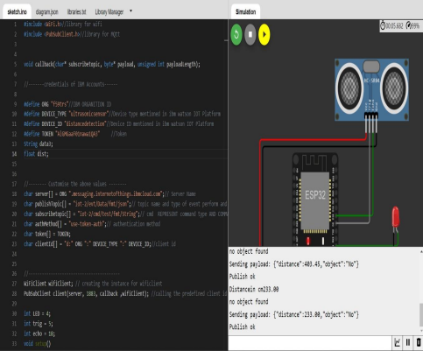

**Data sent to the IBM cloud device when the object is far**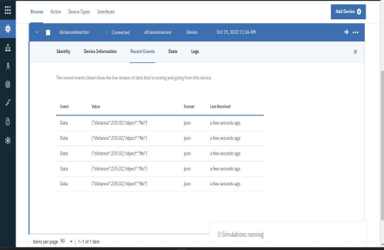

**When object is nearer to the ultrasonic sensor**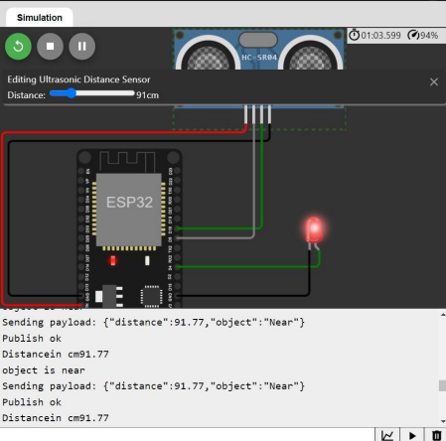

**Data sent to the IBM cloud device when the object is near**